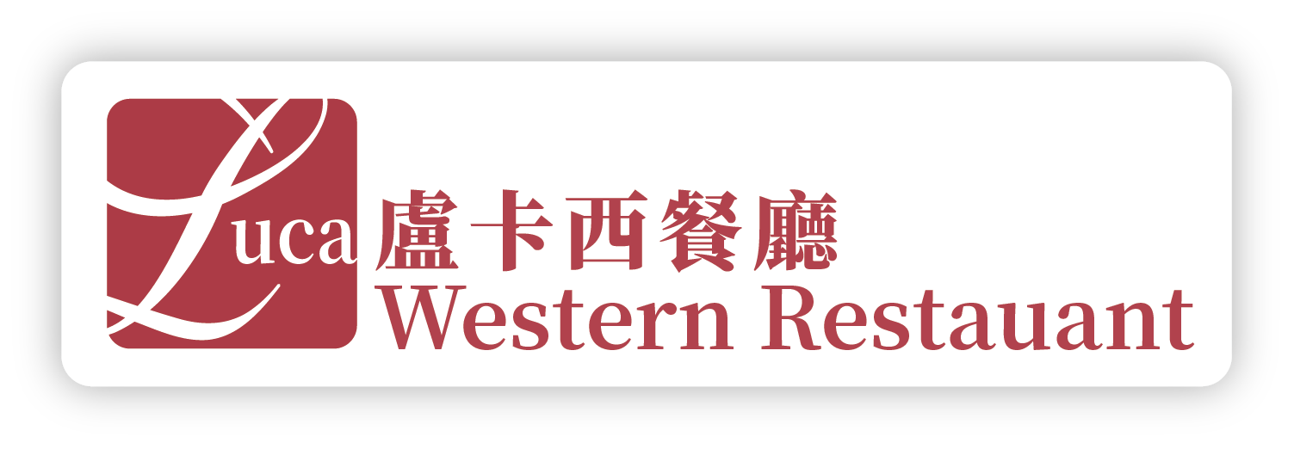

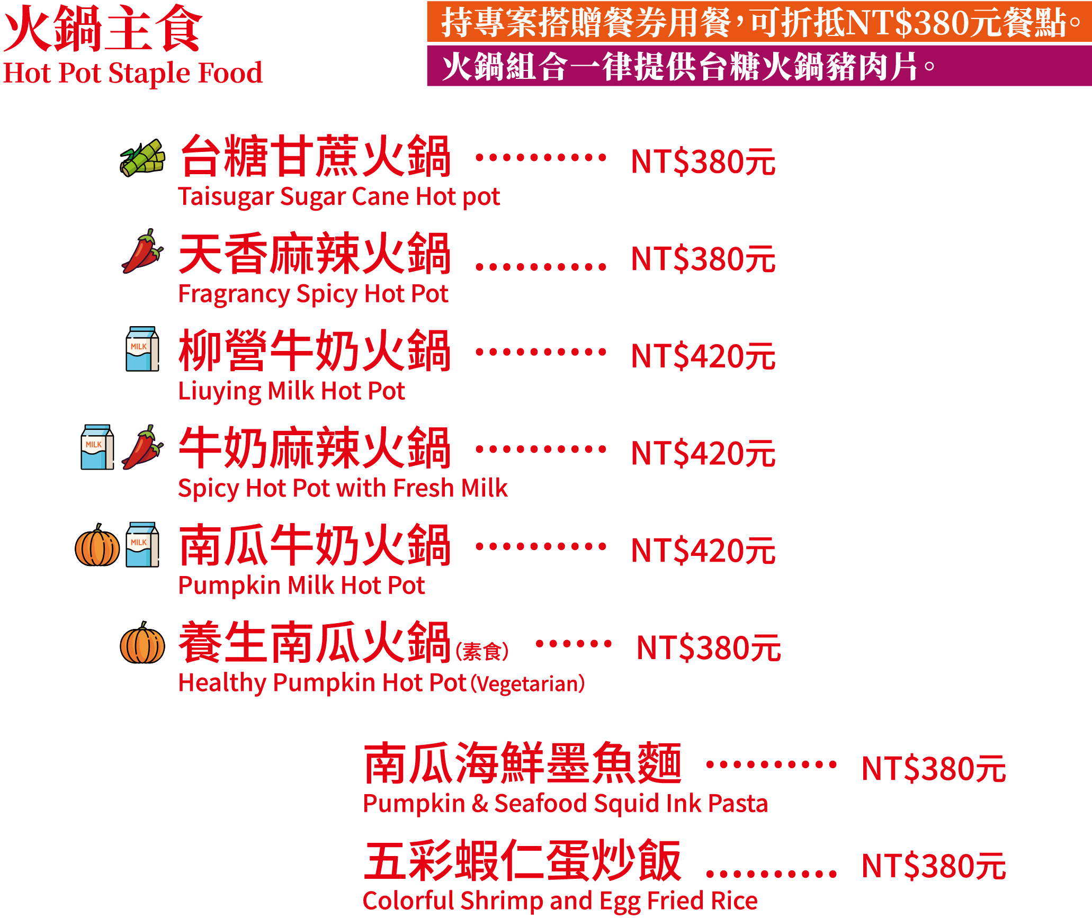
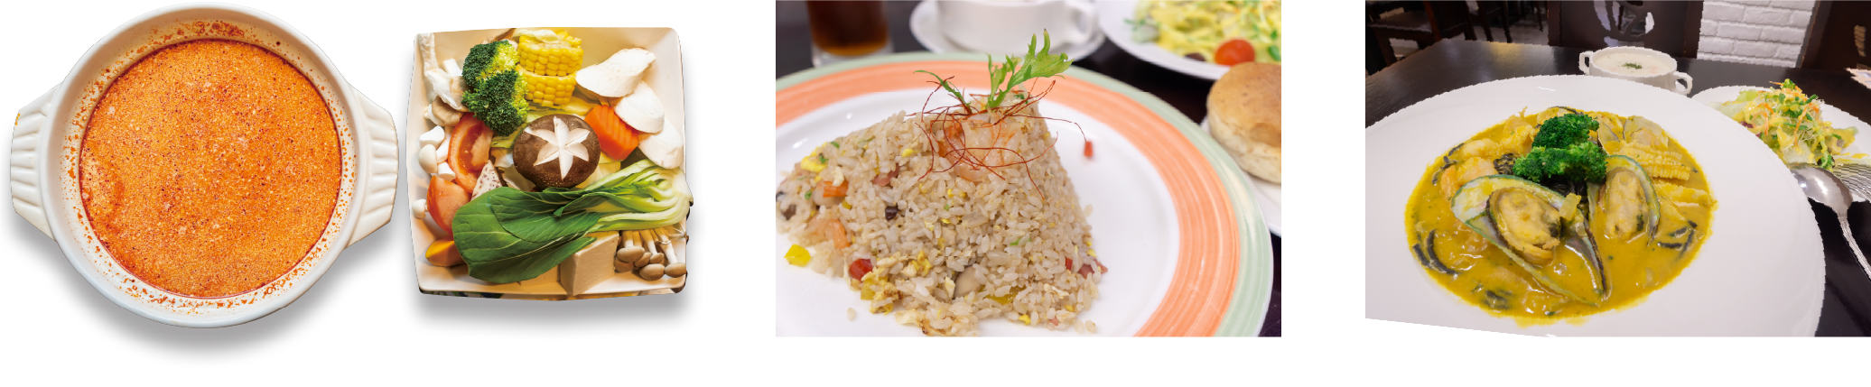
身高115cm以下幼童不另收費用，115cm以上貴賓共鍋需加收低消150元/每人，售價需另加10%服務費。

Children under 115 cm in height are free of charge. For guests over 115 cm sharing a pot, a minimum charge of NT$150 per person applies. All prices are subject to a 10% service charge.

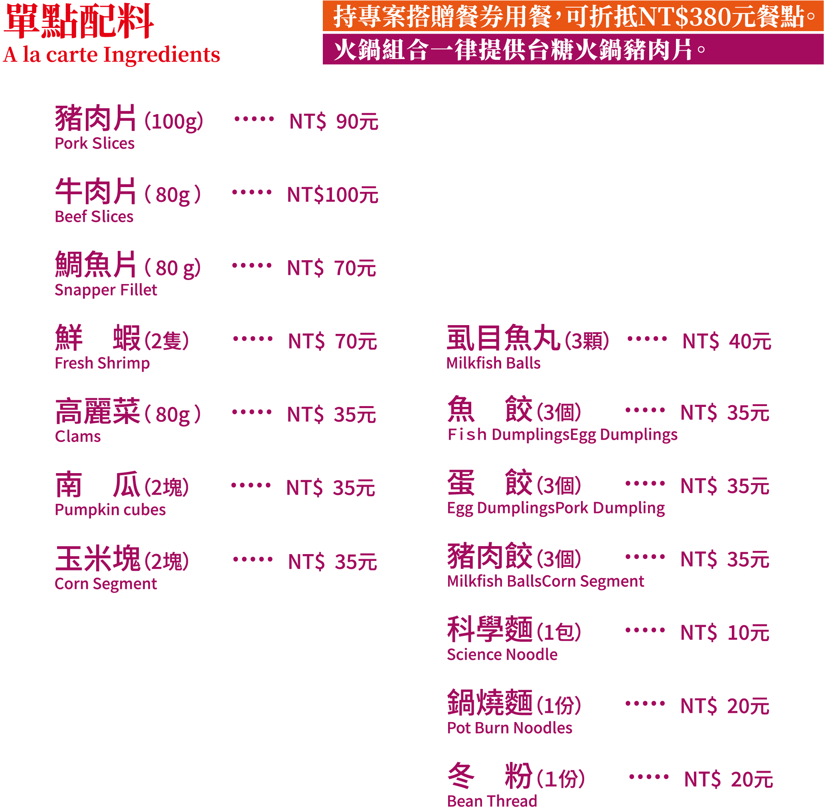
身高115cm以下幼童不另收費用，115cm以上貴賓共鍋需加收低消150元/每人，售價需另加10%服務費。

Children under 115 cm in height are free of charge. For guests over 115 cm sharing a pot, a minimum charge of NT$150 per person applies. All prices are subject to a 10% service charge.

